Storyboard:

In this game we will use the motion control to control hamster :

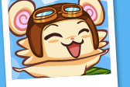 fly in the screen and then fight enemies to rescue it’s friend.

The main menu will like the following scratch: it will have chance to set the difficulty of the game. When in the game , at one level we can see it’s score and we will meet enemies and meet where we can improve our lives. If possible, we will also have chance to win a cookie if we have score over 1000. We also have a boss owl which will attack the hamster, only after winning him will the hamster finally rescue his friend.

